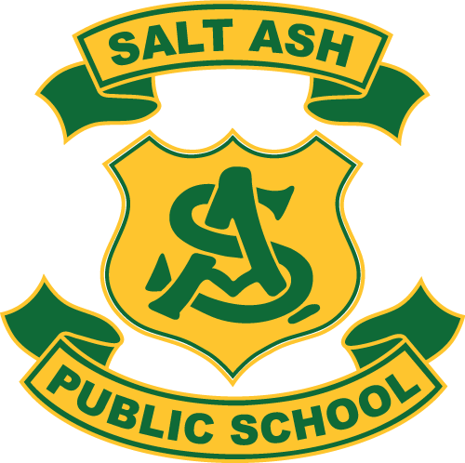
28th^{nd} November, 2016

Music Lessons at School 2017
Dear Families
In 2017 students have an opportunity to participate in piano or keyboard lessons during school time.
These lessons are optional and are provided by an external company, Primary Music Institute PMI.
PMI coordinates everything from instruments and teachers to curriculum and payments.
The school will provide the learning space and timetable the lessons so students don’t miss the same school lesson each week. The school will also verify the music teachers Working With Children Check clearance.
If you would like your child to participate in this program please complete the note that came home last week and send it off to PMI.
Spare notes are available at the school office.
Regards

Andrew Price
Relieving Principal

