Stage 3 ‘In Focus’
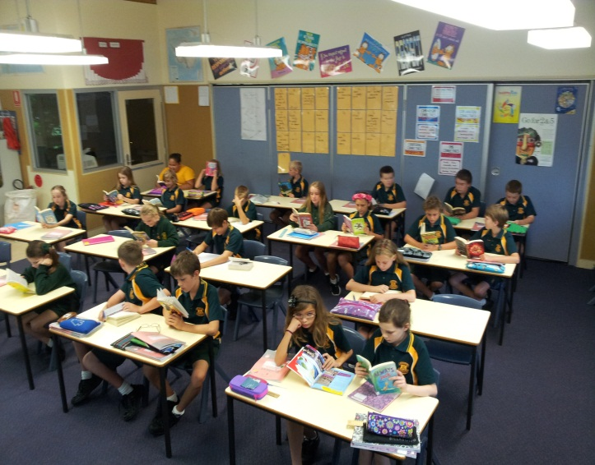
Stage 3 are settled and working well in class. They have been a little overwhelmed with the amount of work there is to get through but a making a good attempt. Many students have demonstrated skill in using new strategies and understanding of concepts.
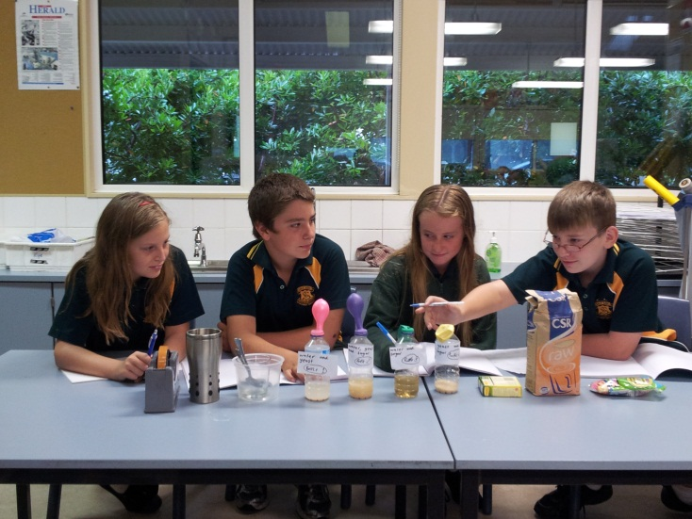
Students have easily settled into their literacy routine and are extremely busy reading, writing and listening. Our daily reading is well established with many groups completing a ‘Daily 3’ of ‘reading to themselves’, ‘reading to someone else’ and ‘listening to someone read’. This image shows the whole class busy reading.
2014 has also seen the introduction of a new science program ‘Primary Connections’ which is aligned with the Australian Curriculum. Year 5 and Year 6 students have been working on different topics and lessons related to biological science. Year 6 have conducted experiments to learn about ‘micro-organisms’. They have used their senses to record observations as well as combined yeast, sugar and water to produce a reaction of carbon dioxide. The students have been thoroughly engaged with this content and have impressed with their interpretations of what has occurred. (Though I have had to assure them it is highly unlikely they will be eaten alive by a micro-organism)
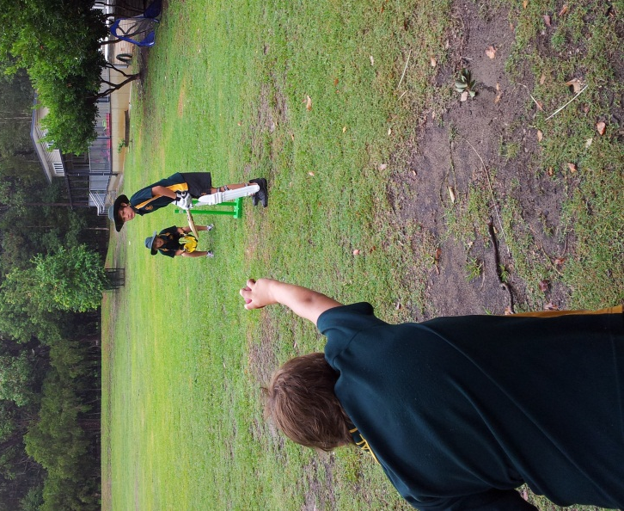
Finally, on top of the swimming carnivals that one student is still involved in, Stage 3 have been determinedly preparing for our PSSA Cricket and Netball events. The girls will play in Netball Gala day in Wk 7 whilst a combined boy/girl team will take on Tanilba Bay in cricket that same week. WELL DONE! Students are making a sacrifice of their own time to train for these events and I have been impressed by the maturity show to improve their skills. I have a good feeling we should continue our winning streak over our neighbouring school!

